ST. XAVIER’S COLLEGE

**(Affiliated to Tribhuvan University)**

**Maitighar, Kathmandu**



**Database Management System**

**Theory Lab Assignment #2**

**SUBMITTED BY:**

Sneha Prasai

013BSCCSIT040

**SUBMITTED TO**

|  |  |
| --- | --- |
| **Mr. Sanjay Kr. Yadav**  **( Lecturer )** |  |
| **Department of Computer Science** | |

**SIMPLIFIED DATABASE SYSTEM OF ORGANIZATION:**

A **database system** is a [computer program](https://simple.wikipedia.org/wiki/Computer_program) for managing electronic databases. A very simple example of a database system would be an electronic [address book](https://simple.wikipedia.org/w/index.php?title=Address_book&action=edit&redlink=1).

The data in a database is organized in some way. Before there were computers, employee data was often kept in [file cabinets](https://simple.wikipedia.org/w/index.php?title=File_cabinet&action=edit&redlink=1). There was usually one card for each employee. On the card, information such as the date of birth or the name of the employee could be found. A database also has such "cards". To the user, the card will look the same as it did in old times, only this time it will be on the screen. To the computer, the information on the card can be stored in different ways. Each of these ways is known as a [database model](https://simple.wikipedia.org/w/index.php?title=Database_model&action=edit&redlink=1). The most commonly used database model is called relational database model; it uses [relations](https://simple.wikipedia.org/wiki/Relation_(mathematics)) and [sets](https://simple.wikipedia.org/wiki/Set) to store the data. Normal users talking about the database model will not talk about relations, they will talk about [database tables](https://simple.wikipedia.org/w/index.php?title=Database_table&action=edit&redlink=1).

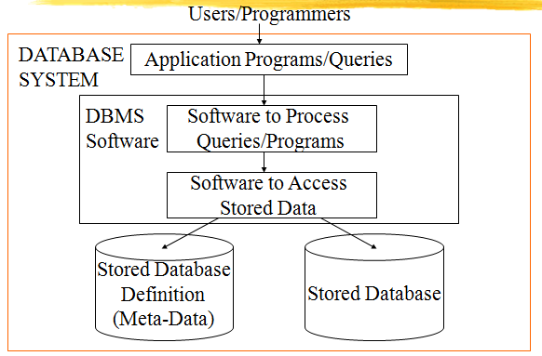

**APPROACHES OF MANAGEMENT OF DATA:**

Data management is the development and execution of architectures, policies, practices and procedures in order to manage the information lifecycle needs of an enterprise in an effective manner.

**Database of approach:** The Database is a shared collection of logically related data, designed to meet the [information](http://ecomputernotes.com/fundamental/information-technology/what-do-you-mean-by-data-and-information) needs of an organization. A database is a [computer](http://ecomputernotes.com/fundamental/introduction-to-computer/what-is-computer) based record keeping system whose over all purpose is to record and maintains information. The database is a single, large repository of data, which can be used simultaneously by many departments and users. Instead of disconnected files with redundant data, all data items are integrated with a minimum amount of duplication.

The database is no longer owned by one department but is a shared corporate resource. The database holds not only the organization's operational data but also a description of this data. For this reason, a database is also defined as a self-describing collection of integrated records. The description of the data is known as the Data Dictionary or Meta Data (the 'data about data'). It is the self-describing nature of a database that provides program-data independence.

**File system of approach:** A file system is the method an operating system uses to name files and assign them locations for efficient storage and retrieval. For example, [DOS](http://searchsecurity.techtarget.com/definition/DOS), Windows, [OS/2](http://whatis.techtarget.com/definition/OS-2),[Macintosh](http://whatis.techtarget.com/definition/Macintosh) and [Unix](http://searchenterpriselinux.techtarget.com/definition/Unix)-based operating systems ([OSes](http://whatis.techtarget.com/definition/operating-system-OS)) all have file systems in which files are placed somewhere in a hierarchical[(tree) structure](http://searchdatamanagement.techtarget.com/definition/tree-structure). A file is placed in a[directory](http://searchwinit.techtarget.com/definition/directory) ([folder](http://whatis.techtarget.com/definition/folder) in Windows) or subdirectory at the desired place in the tree structure.

**DATABASE VS FILE SYSTEM APPROACH:**